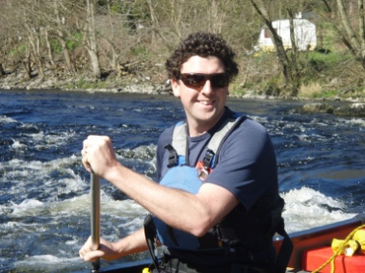
Dordogne in the Spring (Wild camping)
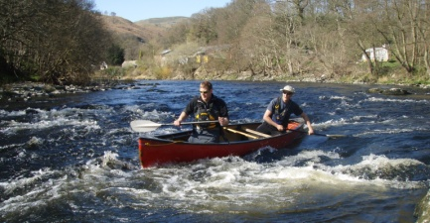
A+ ‘Active Retreats’: ‘Out there - in Him’
Itinerary: Saturday 25th – Wednesday 29th April 2020

Saturday 25th: Fly Ryan Air Stansted Dep 07.20 > Brive, Dordogne arr 10:05 am. A+ bus from Airport > Argentat riverside campsite.
Welcome: Lunch, set camp. Tandem canoe skills coaching, & introduction to shelter building & cooking over an open fire.
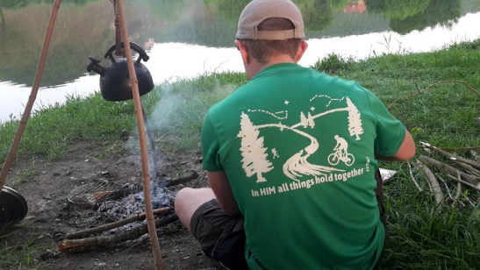
Cook dinner. River Briefing & Intro to ‘Out there – In Him’. Sleep.
Sunday. River Day: River Day. Journey to suitable overnight camp spot. Set up ‘Wild Camp 1’.
Cook dinner over open fire. ‘Out there - In Him’ thought: ‘Rock’. Sleep in tarp shelters.
Monday. River Day: Canoe to ‘Wild camp 2’. Food order to A+ team (to buy provisions from Supermarché)
for evening meal Cooking Team. Arrive at ‘Wild Camp 2’. Set up camp. Cook dinner.
Evening thought: ‘Out There – In Him: Water’
Tuesday. River Day: Breakfast. Strike camp. journey to final campsite. Set up camp.. ‘Out there - In Him: Still, In Him’
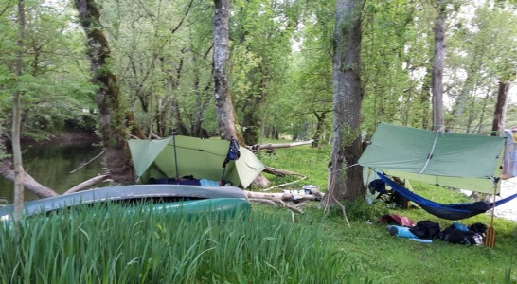
Evening meal out (not included in A+ price). Shower to be ‘fit for public travel’ !
Wednesday 29th: Breakfast at Riverside campsite. Strike camp, pack & leave in A+ bus for Brive for 12.40 flight.
Meals: Each paddler will be linked with a co-chef from among the group to produce an evening meal & a breakfast for the group during the trip, to get the experience of communal cooking over an open fire (or over a BBQ when in public camp site). You pick the menu & A+ will help source the food.

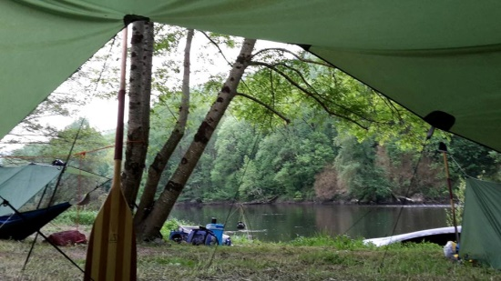
£245 pp includes all canoe kit hire, coaching in canoe & bushcraft skills. Camping kit list to follow.
NB: Travel to & from the area is not included in the price
A+ Active Retreats: an island in the fast flow of modern life. Take a rest and learn new outdoor skills.
Some will also want to take the opportunity to reset priorities & their focus before returning to home. ‘Out there – In Him’: Getting out into the beauty of this wonderful world God has given us to enjoy… to be refreshed & encouraged and a chance to
Reflect on the characteristics of the Creator God, as revealed in His Creation.

